**Case Study : CloudFormation**

**Problem Statement:**

**You work for XYZ Corporation. Your corporation wants to launch a new**

**web-based application. The development team has prepared the code but it is**

**not tested yet. The development team needs the system admins to build a web**

**server to test the code but the system admins are not available.**

**Tasks To Be Performed:**

1. Web tier: Launch an instance in a public subnet and that instance should

allow HTTP and SSH from the internet.

2. Application tier: Launch an instance in a private subnet of the web tier and

it should allow only SSH from the public subnet of Web Tier-3.

3. DB tier: Launch an RDS MYSQL instance in a private subnet and it should

allow connection on port 3306 only from the private subnet of Application

Tier-4.

4. Setup a Route 53 hosted zone and direct traffic to the EC2 instance.

**You have been also asked to propose a solution so that:**

1. Development team can test their code without having to involve the system

admins and can invest their time in testing the code rather than

provisioning, configuring and updating the resources needed to test the

code.

2. Make sure when the development team deletes the stack, RDS DB

instances should not be deleted.

Given below code is to create the resources

AWSTemplateFormatVersion: 2010-09-09

Parameters:

  InstanceTypeParameter:

    Type: String

    Default: t2.micro

    Description: Enter instance size. Default is t2.micro.

  AMI:

    Type: String

    Default: ami-066784287e358dad1  #change the ami id

    Description: The Ubuntu AMI to use.

  Key:

    Type: AWS::EC2::KeyPair::KeyName

    Description: Select from Existing Keys.

  MasterUsername:

    Type: String

    Description: The username for the database.

  MasterUserPassword:

    Type: String

    Description: The password for the database.

    "NoEcho": true

Resources:

  VPC:

    Type: AWS::EC2::VPC

    Properties:

      CidrBlock: 10.10.0.0/16

      EnableDnsSupport: true

      EnableDnsHostnames: true

      InstanceTenancy: default

      Tags:

        - Key: Name

          Value: VPCAssessment

  InternetGateway:

    Type: AWS::EC2::InternetGateway

    Properties:

      Tags:

        - Key: Name

          Value: InternetGatewayAssessment

  VPCGatewayAttachment:

    Type: AWS::EC2::VPCGatewayAttachment

    Properties:

      VpcId: !Ref VPC

      InternetGatewayId: !Ref InternetGateway

  #Public Subnet

  SubnetA:

    Type: AWS::EC2::Subnet

    Properties:

      VpcId: !Ref VPC

      CidrBlock: 10.10.1.0/24

      MapPublicIpOnLaunch: true

      Tags:

        - Key: Name

          Value: PublicSubnetAssessment

  PublicRouteTable:

    Type: AWS::EC2::RouteTable

    Properties:

      VpcId: !Ref VPC

      Tags:

        - Key: Name

          Value: RouteTablePublicSubnet

  PublicInternetRoute:

    Type: AWS::EC2::Route

    DependsOn: VPCGatewayAttachment

    Properties:

      DestinationCidrBlock: 0.0.0.0/0

      GatewayId: !Ref InternetGateway

      RouteTableId: !Ref PublicRouteTable

  SubnetARouteTableAssociation:

    Type: AWS::EC2::SubnetRouteTableAssociation

    Properties:

      RouteTableId: !Ref PublicRouteTable

      SubnetId: !Ref SubnetA

  #Private Subnet

  SubnetB:

    Type: AWS::EC2::Subnet

    Properties:

      VpcId: !Ref VPC

      CidrBlock: 10.10.2.0/24

      MapPublicIpOnLaunch: false

      Tags:

        - Key: Name

          Value: PrivateSubnetAssessment

  # A NAT Gateway:

  NATGateway:

   Type: AWS::EC2::NatGateway

   Properties:

     AllocationId: !GetAtt ElasticIPAddress.AllocationId

     SubnetId: !Ref SubnetA

     Tags:

     - Key: Name

       Value: NatGetwayAssessment

  ElasticIPAddress:

    Type: AWS::EC2::EIP

    Properties:

      Domain: VPC

  RouteTablePrivate:

    Type: AWS::EC2::RouteTable

    Properties:

      VpcId: !Ref VPC

      Tags:

        - Key: Name

          Value: RouteTablePrivateSubnet

  NATRoute:

    DependsOn: NATGateway

    Type: AWS::EC2::Route

    Properties:

      RouteTableId: !Ref RouteTablePrivate

      DestinationCidrBlock: 0.0.0.0/0

      NatGatewayId: !Ref NATGateway

  SubnetBRouteTableAssociationPrivate:

    Type: AWS::EC2::SubnetRouteTableAssociation

    Properties:

      RouteTableId: !Ref RouteTablePrivate

      SubnetId: !Ref SubnetB

  InstanceSecurityGroup:

    Type: AWS::EC2::SecurityGroup

    Properties:

      GroupName: "Internet Group"

      GroupDescription: "SSH and web traffic in, all traffic out."

      VpcId: !Ref VPC

      SecurityGroupIngress:

        - IpProtocol: tcp

          FromPort: '22'

          ToPort: '22'

          CidrIp:  0.0.0.0/0

        - IpProtocol: tcp

          FromPort: '80'

          ToPort: '80'

          CidrIp:  0.0.0.0/0

      SecurityGroupEgress:

        - IpProtocol: -1

          CidrIp: 0.0.0.0/0

  InstanceSecurityGroupPrivate:

    Type: AWS::EC2::SecurityGroup

    Properties:

      GroupName: "Security Group Private"

      GroupDescription: "SSH from the Public Subnet"

      VpcId: !Ref VPC

      SecurityGroupIngress:

        - IpProtocol: tcp

          FromPort: '22'

          ToPort: '22'

          CidrIp:  10.10.1.0/24

      SecurityGroupEgress:

        - IpProtocol: -1

          CidrIp: 0.0.0.0/0

  InstanceSecurityGroupDataBase:

    Type: "AWS::EC2::SecurityGroup"

    Properties:

      GroupDescription: "Database instances security group"

      VpcId: !Ref VPC

      SecurityGroupIngress:

          - IpProtocol: tcp

            CidrIp: 10.10.2.0/24

            FromPort: 3306

            ToPort: 3306

      SecurityGroupEgress:

          - IpProtocol: -1

            CidrIp: 0.0.0.0/0

  RDSDBSubnetGroup:

    Type: "AWS::RDS::DBSubnetGroup"

    Properties:

        DBSubnetGroupDescription: "Subnet Group for mySQL database"

        DBSubnetGroupName: !Sub "${AWS::Region}-aws-database-subnet-group14"

        SubnetIds:

          - !Ref SubnetA

          - !Ref SubnetB

        Tags:

          - Key: Name

            Value: DBSubnetGroup

  RDSDBInstance:

        Type: AWS::RDS::DBInstance

        Properties:

            DBInstanceIdentifier: DBAssessment12

            AllocatedStorage: 20

            DBInstanceClass: db.t3.micro

            Engine: "MYSQL"

            MasterUsername: !Ref MasterUsername

            MasterUserPassword: !Ref MasterUserPassword

            MultiAZ: false

            EngineVersion: 8.0.35

            AutoMinorVersionUpgrade: true

            PubliclyAccessible: false

            StorageType: gp2

            Port: 3306

            StorageEncrypted: false

            CopyTagsToSnapshot: true

            EnableIAMDatabaseAuthentication: false

            DeletionProtection: true

            DBSubnetGroupName: !Ref RDSDBSubnetGroup

            VPCSecurityGroups:

              - !Ref InstanceSecurityGroupDataBase

            MaxAllocatedStorage: 1000

            Tags:

              - Key: Name

                Value: DBAssessment

              - Key: createdBy

                Value: Igor Silva

              - Key: Project

                Value: AssessmentModule7

              - Key: Environment

                Value: Prod

  LinuxPublic:

    Type: 'AWS::EC2::Instance'

    Properties:

      SubnetId: !Ref SubnetA

      ImageId: !Ref AMI

      InstanceType: !Ref InstanceTypeParameter

      KeyName: !Ref Key

      SecurityGroupIds:

        - Ref: InstanceSecurityGroup

      Tags:

        - Key: Name

          Value: LinuxPublic

  LinuxPrivate:

    Type: 'AWS::EC2::Instance'

    Properties:

      SubnetId: !Ref SubnetB

      ImageId: !Ref AMI

      InstanceType: !Ref InstanceTypeParameter

      KeyName: !Ref Key

      SecurityGroupIds:

        - Ref: InstanceSecurityGroupPrivate

      Tags:

      - Key: Name

        Value: LinuxPrivate

  HostedZone:

    Type: AWS::Route53::HostedZone

    Properties:

      HostedZoneConfig:

        Comment: ''

      Name: newpracticedomain.ml

  MyDNSRecord:

    Type: AWS::Route53::RecordSet

    Properties:

      HostedZoneId: !Ref HostedZone

      Name: www.newpracticedomain.ml.

      Type: A

      TTL: 300

      ResourceRecords:

      - !GetAtt LinuxPublic.PublicIp

Outputs:

  PublicIp:

   Description: Server's PublicIp Address

   Value:

     Fn::GetAtt:

       - LinuxPublic

       - PublicIp

  HostedZoneID:

    Description: The ID of the Hosted Zone.

    Value:

      Ref: HostedZone

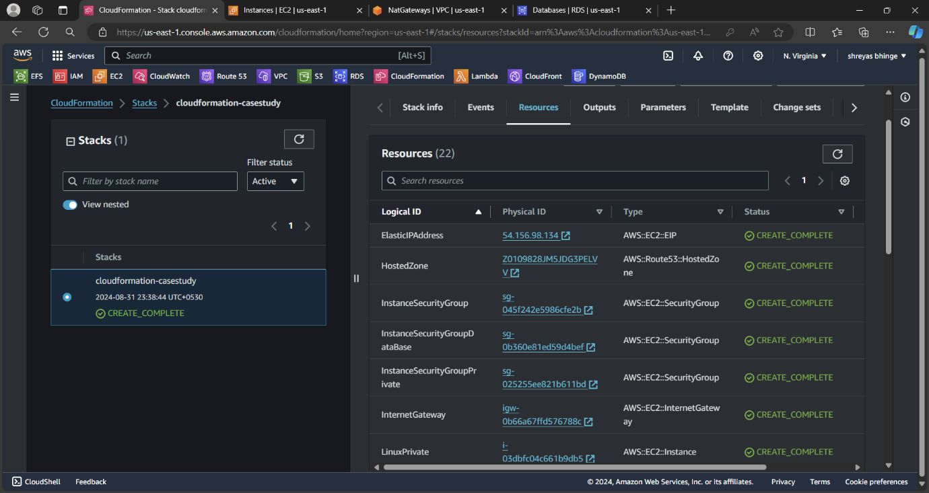

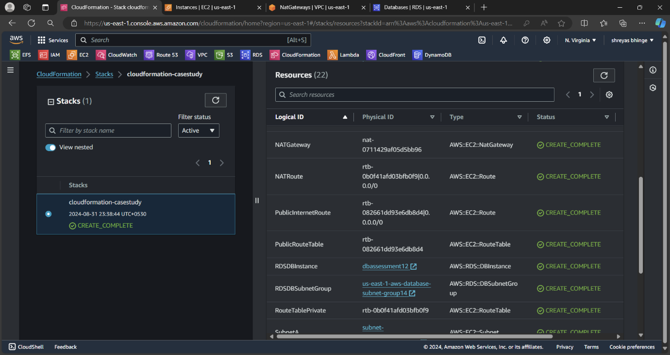

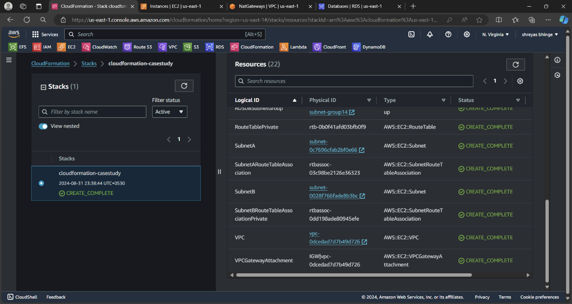

After Deleting stack

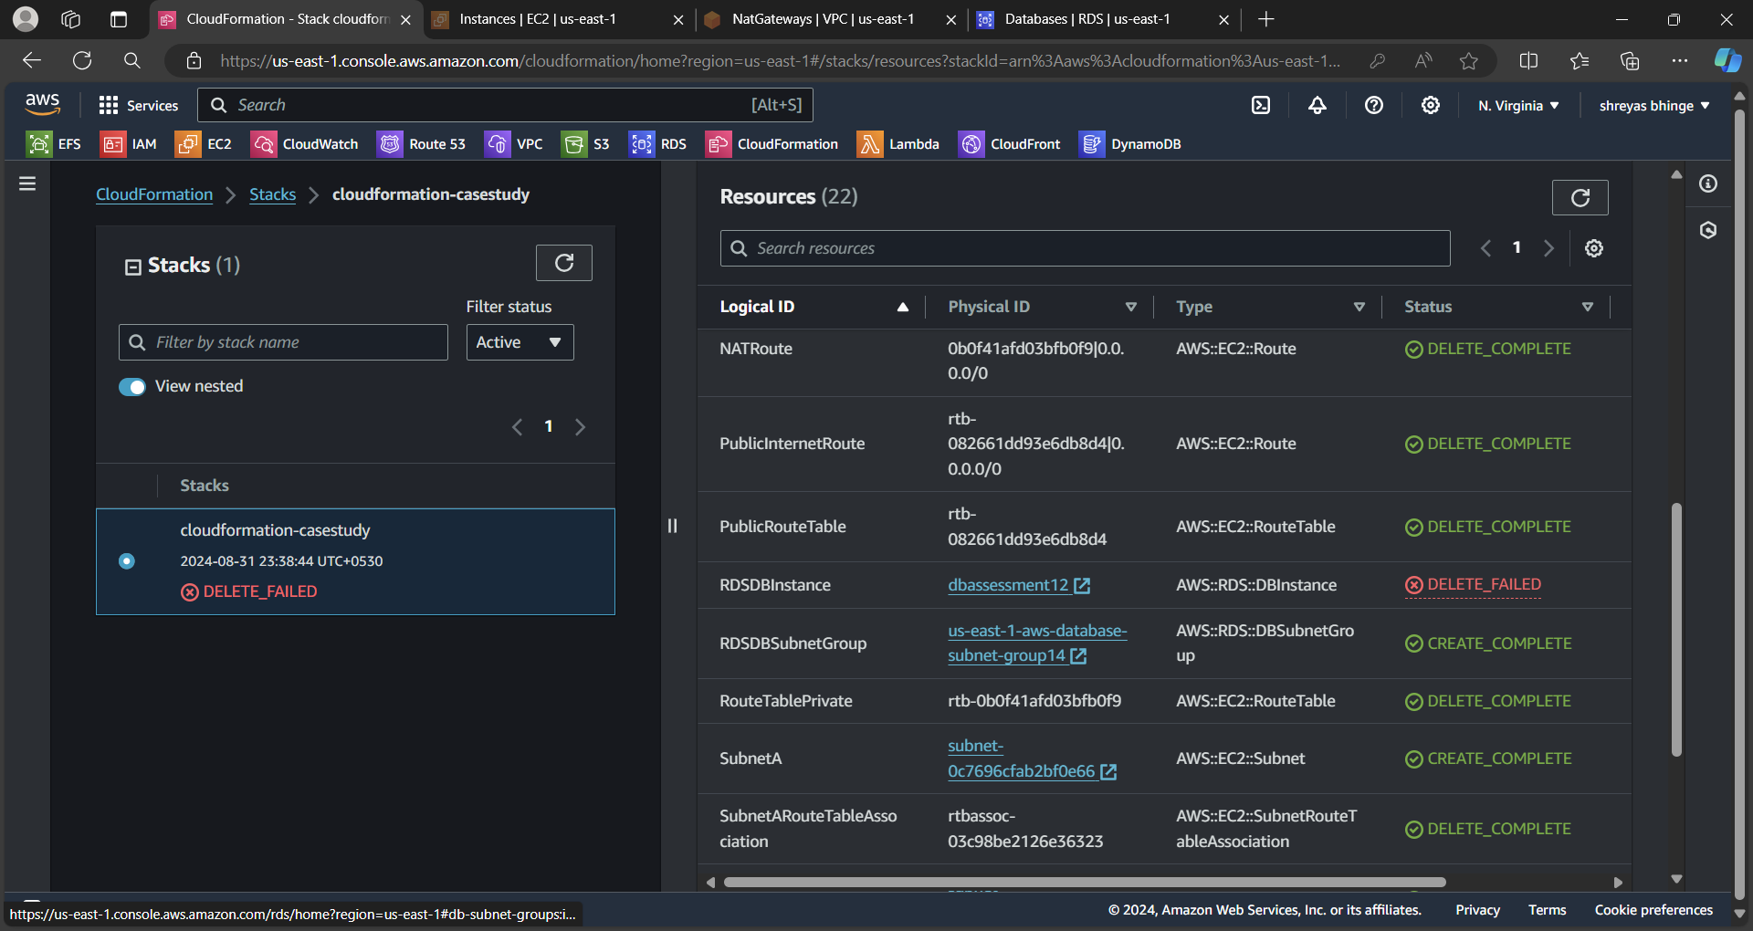

The RDSDB has not been Deleted as mention in template